Chapter from:

Power Electronics and Electric Drivesfor Traction Applications

GONZALO ABADMondragon University, Spain

Railway traction 221Xabier Agirre and Gonzalo Abad5.1 Introduction 221  
5.2 General description 221  
5.3 Physical approach 248  
5.4 Electric drive in railway traction 255  
5.5 Railway power supply system 276  
5.6 ESSs for railway applications 278  
5.7 Ground level power supply systems 332  
5.8 Auxiliary power systems for railway applications 338  
5.9 Real examples 340  
5.10 Historical evolution 351  
5.11 New trends and future challenges 351  
References 35

# **5.2 General description 221**

## Two types of electrification: DC and AC;

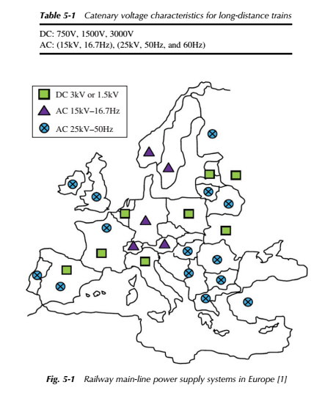

## Types of vehicles:

Tram

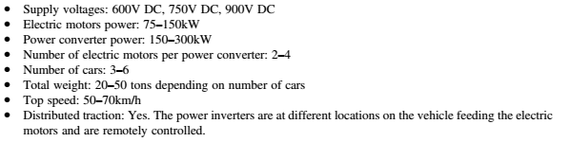

Metro

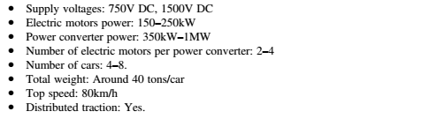

Train

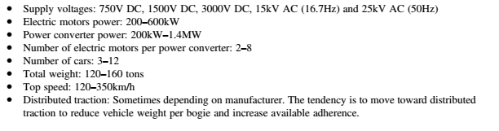

Locomotive



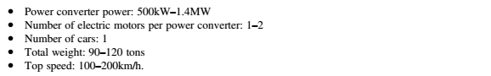

## Type of bogies

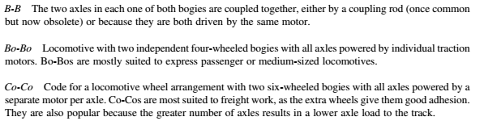

# Vehicle power architecture

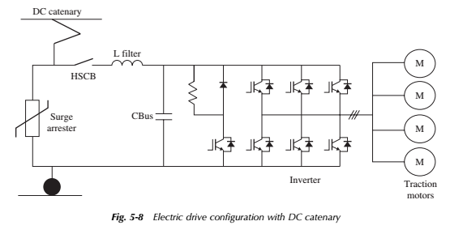

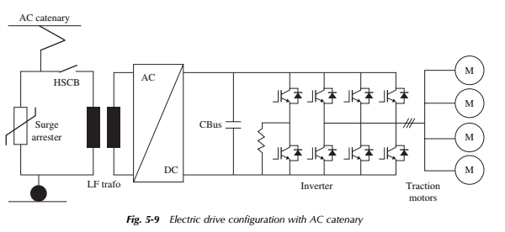

# Power system components classification

* Pantograph
  + The pantograph is a device capable of maintain an electrical contact between train and catenary while in motion.
* Surge arrester
  + This equipment ensures over-voltage protection of train internal circuit, against external events (such as lightings) or internal events (switching)
* High-speed circuit breaker
  + This device allows the interruption of extra-high current faults.
* Input LC filter
  + The main objective is to improve the power quality of the energy supply with the reduction of harmonic distortion (with the absorption of high frequency harmonics and injection of low frequency harmonics)
* Filter inductor and DC-link capacitor
  + Coupled with electronic power converters/inverters, the filter inductor and DC-link capacitor allows the rectification of the AC voltage into DC
* Power semiconductors
  + 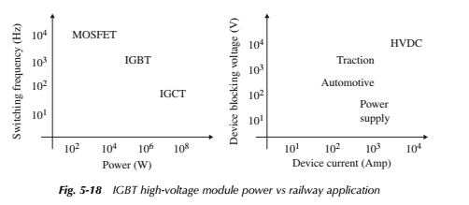
* Braking resistor
  + Avoid dangerous DC-link voltages (if the main AC grid does not support the generated energy)
* Power converter box
  + Includes the power semiconductors (in power inverter arrangement) and cooling media.
* Electric traction motor
  + Enables mechanical propulsion. The most common technology is the squirrel cage induction motor

# 5.3 Physical approach 248

* Forces:
  + Ftrain: forces created within the train (positive if accelerating or negative if braking)
  + Fext: External forces created outside the train (like air resistance, gravity acceleration, etc)
* Adhesion
  + Coefficient related to forces between driving wheel and rail

# 5.4 Electric drive in railway traction 255

* Traction supply:
  + DC catenary
  + AC catenary
  + AC catenary with medium frequency transformer
  + 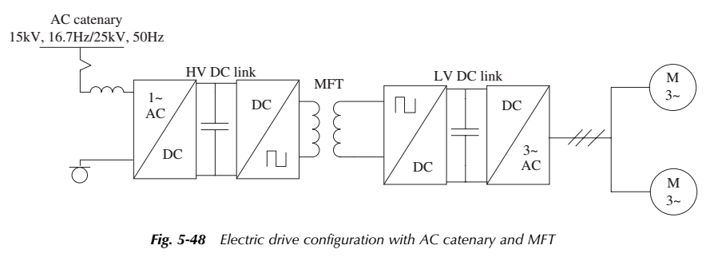
  + Diesel electric traction vehicles
  + 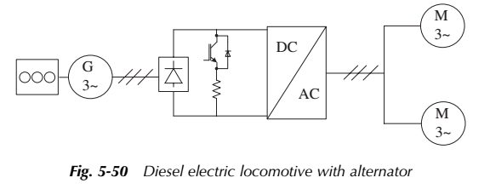
* Electric machines
  + 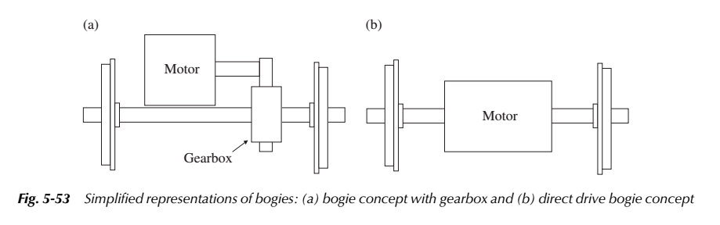
* Control strategy
  + Three level control strategy
    - Level 1: generation of semiconductor pulses (modulation level)
    - Level 2: torque and flux control (rotor flux orientated vector control level)
    - Level 3: generation of torque and flux references (includes antislip control and voltage maintenance)
  + 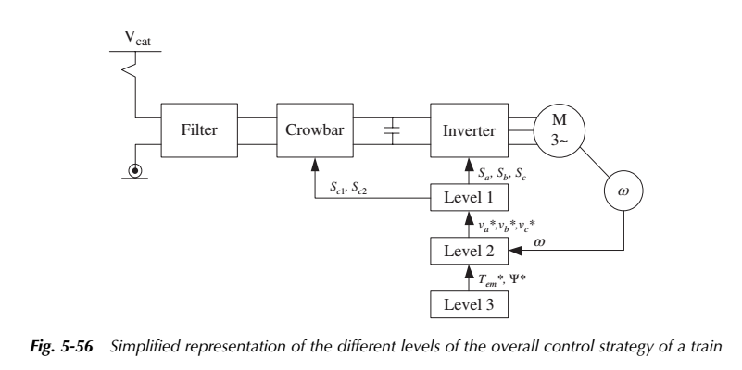

# 5.5 Railway power supply system 276

* DC supply system (six-, 12- or 24-pulse diode rectifiers)
* 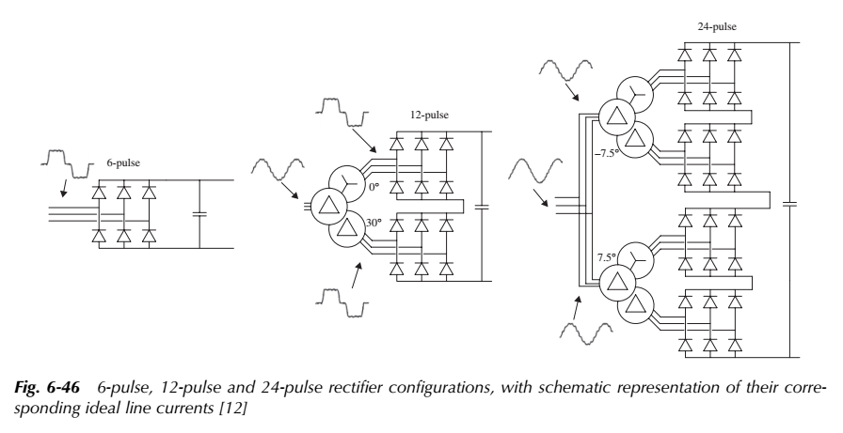
* AC 50Hz (or 60Hz) supply system
  + 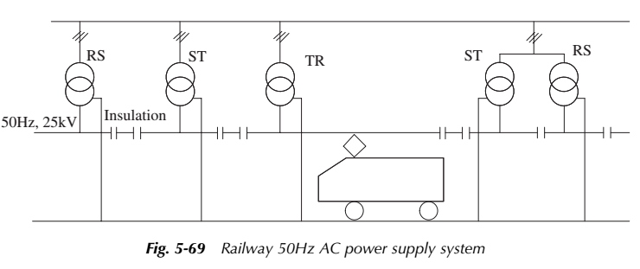
* AC 16.7Hz supply systems
  + 